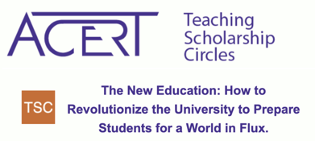

What kind of support do Hunter faculty need the most?

- Course releases and other forms of funding in order to redo/rethink courses in thoughtful ways and incorporate technology in ways that support the learning outcomes of the course

- Discussion, exchange and technological support for changing/adapting courses via small tweaks/small changes over time in order to see what works and what doesn’t (like at ACERT bootcamps and through FITT grants, but expanded with administrative support in order to reach more faculty)

- Online trainings like at Lehman-- taking an asynchronous online class helped me to see what would actually work and not work in designing my own course- Preparation for Teaching Online: A Foundational Workshop for CUNY Faculty

- On-line site (perhaps Blackboard, Google, or Commons site) should be created with best practices and perhaps one with space for questions and issues that can be group sourced

  - There are actually multiple CUNY sources available-- but it would be so useful to have it organized-- a single place to go to-- a clearinghouse of sorts? For example, the following come to mind:

    - https://jitp.commons.gc.cuny.edu/ (GC’s Journal of Interactive Technology & Pedagogy)
    - GC Hybrid’s Course Design site: https://tlc.commons.gc.cuny.edu/hybridonline-course-development/
    - York College’s has lots of resources-- this video is particularly useful for students: https://www.york.cuny.edu/academics/academic-affairs/ctlet/for-students/online-hybrid-course-support/study-skills-needed-for-success-in-online-or-hybrid-courses

- Opportunity to collaborate across campuses with other similar departments.

- Transparency in how resources are allocated throughout the college and what plans the administration has for the near future as well as long term goals.

- More funding for professional development, including conferences, short courses, research travel, etc.

