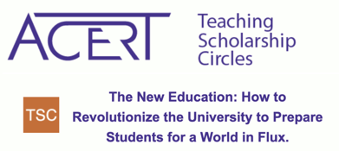

What kind of support do Hunter students need the most?

- financial support so that they can focus on their studies;
  - What about some kind of formal grant that students could use to pay for books, fees, etc., not covered by the Excelsior Scholarship, which only covers tuition? Is this something we could fundraise for?
- help learning to be critical of online sources and technology itself;
- the kinds of support that Honors students receive here at Hunter, but for ALL students; a metro card? :)
- all students should have at least one (or more) workshops with fewer than 15 students; YES!
- all students should get some of the perks of honors students; or even some of the cultural perks worked into their curriculum as well-- for example, when I taught one of the Honors Seminars, we were given money to pay for students to go to LES Tenement Museum-- I would love to be able to do this with other courses, just not possible...
- for students on public assistance, a revamping of the CUNY Edge program goals because too many students are feeling great distress from CUNY Edge demands
- mentoring opportunities
- A real orientation program for both freshman admits and transfers
- Mental health and health services; also peer support for life skills like time and money management, etc.
- A real buffet-style campus dining hall where food will be both affordable and plentiful; also a budget for food support for students who need it
- programming that introduces and meaningfully connects students to the resources here on campus; more spaces for students to access/be trained as peer mentors in navigating Hunter (ie: transfer student mentors)
- How do we create the kind of student engagement, involvement, and the sense of being part of a community at Hunter, in the ways it comes naturally to schools where most students live right on campus, and the campus is the center of their lives?

